Name | Sanchay Ambokar
Roll no | 24204B0046
Batch | 03
Subject name | Python Programming & Data Structure
Teacher Name | Ms. Rasika Patil

Experiments | 12
Title | Implement searching techniques using python  a) Linear Search  b) Binary Search

Programming Questions with Answer
1 | Program for Linear Search
SCRIPT | data = list(map(int, input("Enter elements separated by space: ").split()))  key = int(input("Enter element to search: "))  found = False  for i in range(len(data)):  if data[i] == key:  print("Element found at position", i + 1)  found = True  break  if not found:  print("Element not found")
OP | 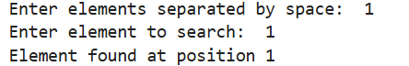
2 | Program for Binary Search
SCRIPT | data = list(map(int, input("Enter sorted elements separated by space: ").split()))  key = int(input("Enter element to search: "))  low = 0  high = len(data) - 1  found = False  while low <= high:  mid = (low + high) // 2  if data[mid] == key:  print("Element found at position", mid + 1)  found = True  break  elif data[mid] < key:  low = mid + 1  else:  high = mid - 1  if not found:  print("Element not found")
OP | 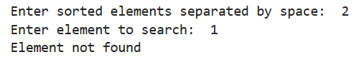
3 | Program to search for a character in a string (Linear Search logic)
SCRIPT | text = input("Enter a string: ")  ch = input("Enter character to search: ")  found = False  for i in range(len(text)):  if text[i] == ch:  print("Character found at position", i + 1)  found = True  break  if not found:  print("Character not found")
OP | 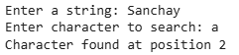
Debugging Questions with Corrected Answers
1 | Debug the following code  Wrong code:  arr = [1,2,3]  for i in arr:  if arr[i] == 2:  print("Found")
OP | Error: 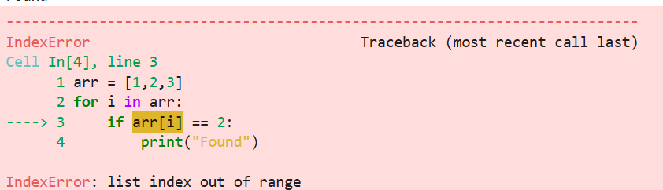  Correct code:  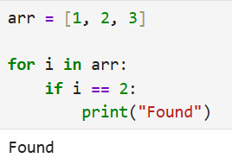
2 | Debug the following code  Wrong code:  low = 0  high = len(arr)  mid = (low + high) / 2
OP | Error: No error  Correct code:  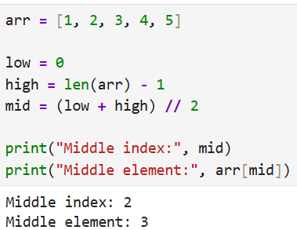
Conclusion

Performance Indicators |  | Teachers Dated and Signature
Process Related  (15 M) | Product Related  (10 M) | Total (25 M)

